EXERCISE 2
%
O0000
(PROGRAM NAME - 20ME076T NC)
(DATE=DD-MM-YY - 31-10-23 TIME=HH:MM - 14:17)
N100G21
N102G0G17G40G49G80G90
(2. FLAT ENDMILL TOOL - 1 DIA. OFF. - 1 LEN. - 1 DIA. - 2.)
N104T1M6
N106G0G90G54X-29.Y27.5Z50.A0.S50M5
N108G43H1Z50.
N110Z10.
N112G1Z-10.F4.5
N114X67.
N116G2X68.Y26.5R1.
N118G1Y0.
N120Y-26.5
N122G2X67.Y-27.5R1.
N124G1X-29.
N126G2X-30.Y-26.5R1.
N128G1Y0.
N130Y26.5
N132G2X-29.Y27.5R1.
N134G0Z50.
N136X-17.931Y-21.742
N138Z10.
N140G1Z1.
N142G2X-19.75Y-19.75Z.845R2.
N144X-17.75Y-17.75Z.68R2.
N146X-17.569Y-17.758Z.671R2.

N148X-15.75Y-19.75Z.516R2.
N150X-17.75Y-21.75Z.351R2.
N152X-17.931Y-21.742Z.341R2.
N154X-19.75Y-19.75Z.186R2.
N156X-17.75Y-17.75Z.022R2.
N158X-17.569Y-17.758Z.012R2.
N160X-15.75Y-19.75Z-.143R2.
N162X-17.75Y-21.75Z-.308R2.
N164X-17.931Y-21.742Z-.317R2.
N166X-19.75Y-19.75Z-.472R2.
N168X-17.75Y-17.75Z-.637R2.
N170X-17.569Y-17.758Z-.646R2.
N172X-15.75Y-19.75Z-.802R2.
N174X-17.75Y-21.75Z-.966R2.
N176X-17.931Y-21.742Z-.976R2.
N178X-19.75Y-19.75Z-1.131R2.
N180X-17.75Y-17.75Z-1.296R2.
N182X-17.569Y-17.758Z-1.305R2.
N184X-15.75Y-19.75Z-1.46R2.
N186X-17.75Y-21.75Z-1.625R2.
N188X-17.931Y-21.742Z-1.634R2.
N190X-19.75Y-19.75Z-1.789R2.
N192X-17.75Y-17.75Z-1.954R2.
N194X-17.569Y-17.758Z-1.964R2.
N196X-15.75Y-19.75Z-2.119R2.
N198X-17.75Y-21.75Z-2.283R2.
N200X-17.931Y-21.742Z-2.293R2.
N202X-19.75Y-19.75Z-2.448R2.
N204X-17.75Y-17.75Z-2.613R2.
N206X-17.569Y-17.758Z-2.622R2.
N208X-15.75Y-19.75Z-2.777R2.
N210X-17.75Y-21.75Z-2.942R2.
N212X-17.931Y-21.742Z-2.951R2.
N214X-19.75Y-19.75Z-3.107R2.
N216X-17.75Y-17.75Z-3.271R2.
N218X-17.569Y-17.758Z-3.281R2.
N220X-15.75Y-19.75Z-3.436R2.
N222X-17.75Y-21.75Z-3.601R2.
N224X-17.931Y-21.742Z-3.61R2.
N226X-19.75Y-19.75Z-3.765R2.
N228X-17.75Y-17.75Z-3.93R2.
N230X-17.569Y-17.758Z-3.939R2.
N232X-15.75Y-19.75Z-4.094R2.
N234X-17.75Y-21.75Z-4.259R2.
N236X-17.931Y-21.742Z-4.269R2.
N238X-19.75Y-19.75Z-4.424R2.
N240X-17.75Y-17.75Z-4.588R2.
N242X-17.569Y-17.758Z-4.598R2.
N244X-15.75Y-19.75Z-4.753R2.
N246X-17.75Y-21.75Z-4.918R2.
N248X-17.931Y-21.742Z-4.927R2.
N250X-19.164Y-21.164Z-5.R2.
N252G1X-20.75Y-22.75
N254X-8.421
N256G2X-6.352Y-21.282R44.75
N258G1X-20.75
N260Y-19.814
N262X-3.999
N264G2X-1.261Y-18.347R44.75
N266G1X-20.75
N268Y-16.879
N270X2.054
N272G2X6.413Y-15.411R44.75
N274G1X-20.75
N276Y-13.943
N278X14.327
N280G2X18.497Y-13.749R44.75
N282X22.666Y-13.943R44.75
N284G1X51.484
N286G2X49.307Y-15.411R17.75
N288G1X30.581
N290G2X34.251Y-16.614R44.75
N292G3X35.008Y-16.879R17.75
N294G1X45.992
N296X53.126Y-12.476
N298X-20.75
N300Y-11.008
N302X54.424
N304G3X55.468Y-9.54R17.75
N306G1X-20.75
N308Y-8.073
N310X56.308
N312X56.975Y-6.605
N314X43.49
N316G3X45.616Y-5.137R7.25
N318G1X57.49
N320G3X57.867Y-3.669R17.75
N322G1X46.753
N324G3X47.408Y-2.202R7.25
N326G1X58.113
N328G3X58.235Y-.734R17.75
N330G1X47.713
N332G3X47.75Y0.R7.25
N334X47.713Y.734R7.25
N336G1X58.235
N338G3X58.113Y2.202R17.75
N340G1X47.408
N342G3X46.753Y3.669R7.25
N344G1X57.867
N346G3X57.49Y5.137R17.75
N348G1X45.616
N350G3X43.49Y6.605R7.25
N352G1X56.975
N354X56.308Y8.073
N356X-20.75
N358Y9.54
N360X55.468
N362G3X54.424Y11.008R17.75
N364G1X-20.75
N366Y12.476
N368X53.126
N370X51.484Y13.943
N372X22.666
N374G3X30.581Y15.411R44.75
N376G1X49.307
N378G3X45.992Y16.879R17.75
N380G1X35.008
N382G3X34.251Y16.614R17.75
N384G2X18.497Y13.749R44.75
N386X14.327Y13.943R44.75
N388G1X-20.75
N390Y15.411
N392X6.413
N394G2X2.054Y16.879R44.75
N396G1X-20.75
N398Y18.347
N400X-1.261
N402G2X-3.999Y19.814R44.75
N404G1X-20.75
N406Y21.282
N408X-6.352
N410G2X-8.421Y22.75R44.75
N412G1X-20.75
N414Y6.605
N416X-2.99
N418G3X-5.116Y5.137R7.25
N420G1X-20.75
N422Y3.669
N424X-6.253
N426G3X-6.908Y2.202R7.25
N428G1X-20.75
N430Y.734
N432X-7.213
N434G3X-7.25Y0.R7.25
N436X-7.213Y-.734R7.25
N438G1X-20.75
N440Y-2.202
N442X-6.908
N444G3X-6.253Y-3.669R7.25
N446G1X-20.75
N448Y-5.137
N450X-5.116
N452G3X-2.99Y-6.605R7.25
N454G1X-20.75
N456G0Z50.
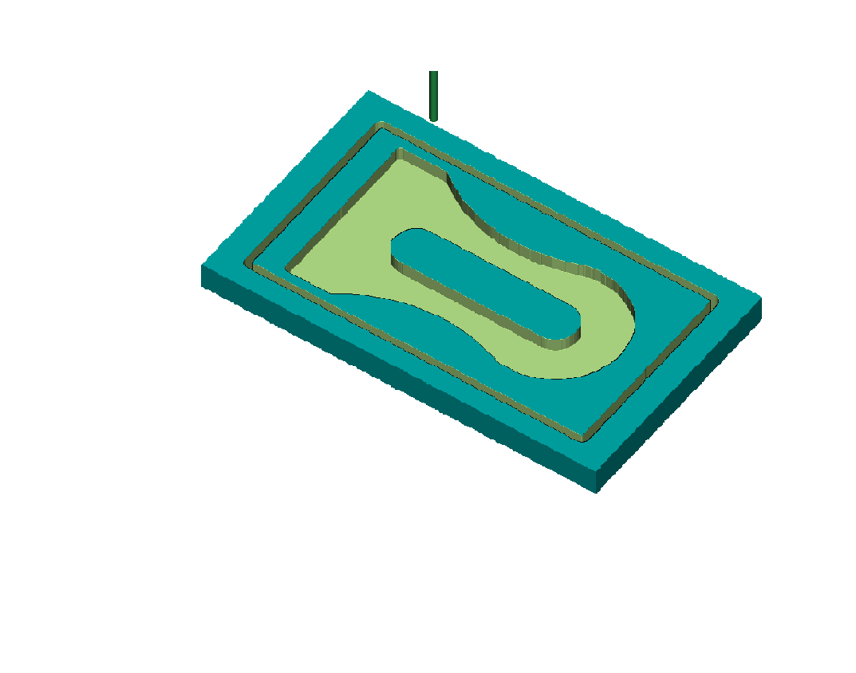
N458X58.5Y0.
N460Z10.
N462G1Z-5.
N464G3X40.5Y18.R18.
N466X34.163Y16.848R18.
N468G2X18.497Y13.999R44.5
N470X-8.338Y23.R44.5
N472G1X-21.
N474Y0.
N476Y-23.
N478X-8.338
N480G2X18.497Y-13.999R44.5
N482X34.163Y-16.848R44.5
N484G3X40.5Y-18.R18.
N486X58.5Y0.R18.
N488G0Z50.
N490X0.Y7.
N492Z10.
N494G1Z-5.
N496X40.5
N498G2X47.5Y0.R7.
N500X40.5Y-7.R7.
N502G1X0.
N504G2X-7.Y0.R7.
N506X0.Y7.R7.
N508G0Z50.
N510M5
N512G91G28Z0.
N514G28A0.
N516M30
%

NAME: TANABAI RAJPUT
USN: 2GI20ME078
SIGNATURE:

